**Ideation Phase**

**Empathize & Discover**

|  |  |
| --- | --- |
| Date | 16 June 2025 |
| Team ID | LTVIP2025TMID35624 |
| Project Name | Revolutionizing Liver Care: Predicting Liver Cirrhosis Using Advanced Machine Learning Techniques |
| Maximum Marks | 4 Marks |

**Empathy Map Canvas:**

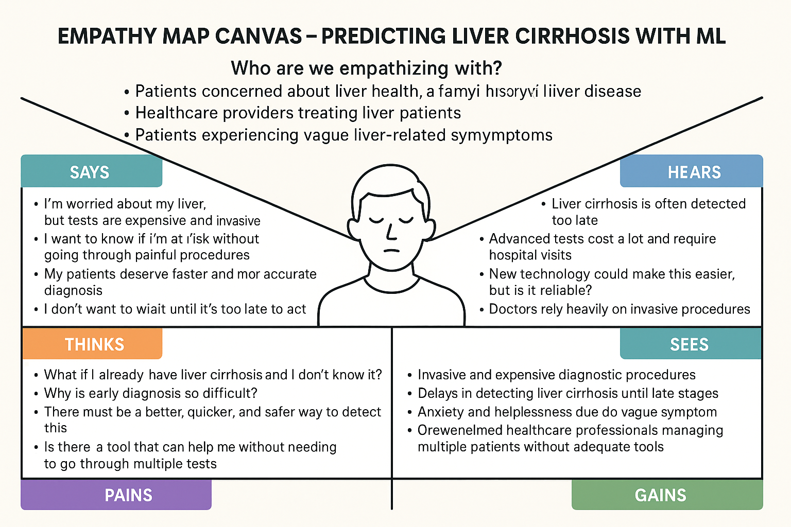

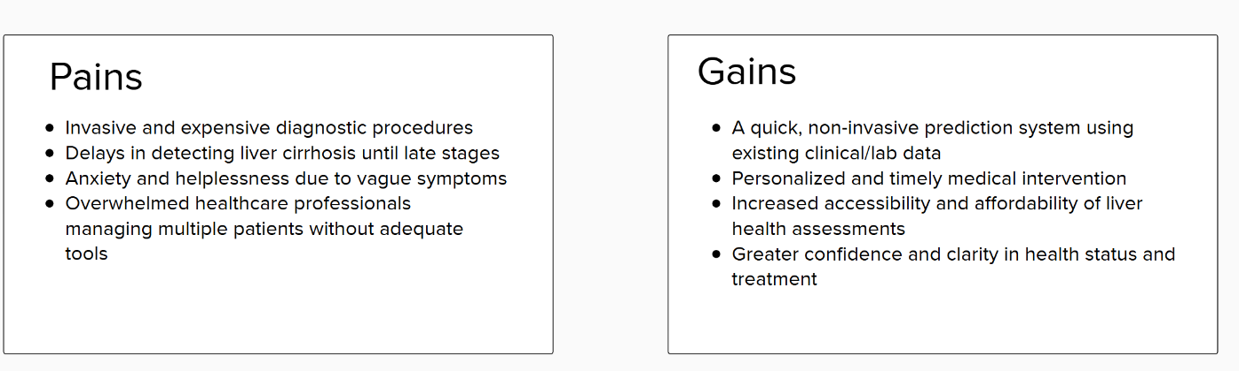

Reference: <https://www.mural.co/templates/empathy-map-canvas>